A New Brewpub in Applebee At Harvard Square
Student’s Name
Institution Affiliated
Course
Instructor’s Name
Date

Contents
Executive Summary 3
1.0 Introduction 4
1.1 Background Information to Brewery 6
1.2 Objective 7
2.0 Business Stimulation Models 7
3.0 Management Analysis 9
3.1 Operations management 9
3.2 Organic organizational structure 11
3.2.1 Advantages of Organic Organization to Brewpub Company 12
3.2.2 Disadvantages of Organic Organization 13
3.3 Hierarchical Organizational structure 13
3.4 Organization and HR Management 14
3.5 Core Competency Management 15
4.0 Strategical Analysis 17
4.1 Quality Control and Decisions Making 17
4.2 Innovation & Technology Management 20
5.0 Financial Analysis 21
5.1 Break-even analysis 21
5.2 Market Share 22
6.0 Conclusion 23
7.0 Recommendations 24
References 26
Appendix 29

Executive Summary
The rationale for investing in a new Brewpub at Applebee in Harvard square involves considering an opportunity by the owner of an existing restaurant/tavern basing on a running case and a business simulation package. The owner considers increasing competition locally by investing more in a new system in brewing craft beer (draught-beer) in the house. In aligning to the rationale in pursuing the proposed venture which seeks to capitalize on both regional and national trends that helps in demonstrating the high interest for craft and beers. The business performance is analyzed for both retentions of critical technology from the start to the current cycle revealing FY-1 at 60.38%, followed by FY-2 at 62.26%, and lastly FY1+FY2+FY3 at 62.89%. Under operational management, the company has a predictable trend analysis showing the possibilities of performance increase within the organization. There was a revenues increase for all the years beginning with year FY-1 = $ 1, 488, 315, FY-2 = $ 1, 555, 660, FY-3 =$ 1,647,218 and again FY1+FY2+FY3 = $ 4,691,193.In addition to that, the revenue collected stood at 83% for both FY-1 and FY-2 and FY-3 taking the lead at 84%. The Applebee Brewpub Company is hierarchical. Different workers work under other managers. Hence, the company's decision process flows from the top management to the different levels of employees. Furthermore, the company has four different levels of employees starting with office assistants, salesmen, executive salaries and miscellaneous (Consultants). The breakeven analysis table revealing that the amount of revenue collected was much higher than the expenses and this proves a point that the company is doing well for every financial year and the profit margin also widens.

1.0 Introduction
The rationale for investing in a new Applebee Brewpub in Harvard Square involves considering an opportunity by the owner of an existing restaurant/tavern basing on a running case and a business simulation package. The owner considers increasing competition locally by investing more in a new system in brewing craft beer (draught-beer) in the house. In aligning to the rationale in pursuing the proposed venture which seeks to capitalize on both regional and national trends that helps in demonstrating the high interest for craft and beers. Showing business simulation model for strategies and decision support in the organization that has stepped in ensuring the success of an organization revealing that input parameters must be put in place such as marketing management, invention and technology management, operations management, financial management, organizational and HR management (Bazzani, 2020). In the decision-making process of any company, organization management is required that helps in realizing if the company is making profits or losses. If the company is making losses then through management it can be used in predicting future profits. Organizational management is a crucial element in the appreciation of a company's weaknesses as well as strengths (Simon, et al., 2020). Companies and various organizations need to understand their weaknesses and strengths to improve and propel them further. It is crucial to realize that organizational management derives an organization's information concerning the performance and the factors that determine success. The stakeholders of an organization or company ought to participate in their formal management to gain insight into the organization's general performance. There is always room to improve even the best services regarding the customers and stakeholders within the company. Companies that plan visualize organizational management as a business opportunity that offers more than just a perspective on the company's weaknesses and strengths. Opportunities and new business frontiers are only realized when the company improves its weaknesses and strengths as it unveils the untapped potential within a company.
When the cycle for Monte-Carlo simulation was performed beginning with cycle 01,02,03,04,05,06 and 07 the results revealed that cycle 1 and 2 scored a similar figure of 2,056,113,followed by cycle 3 and 4 scoring both 2,242,148 and lastly cycle 5 scoring 4,714,568 and cycle 7 scoring 4,691,193.
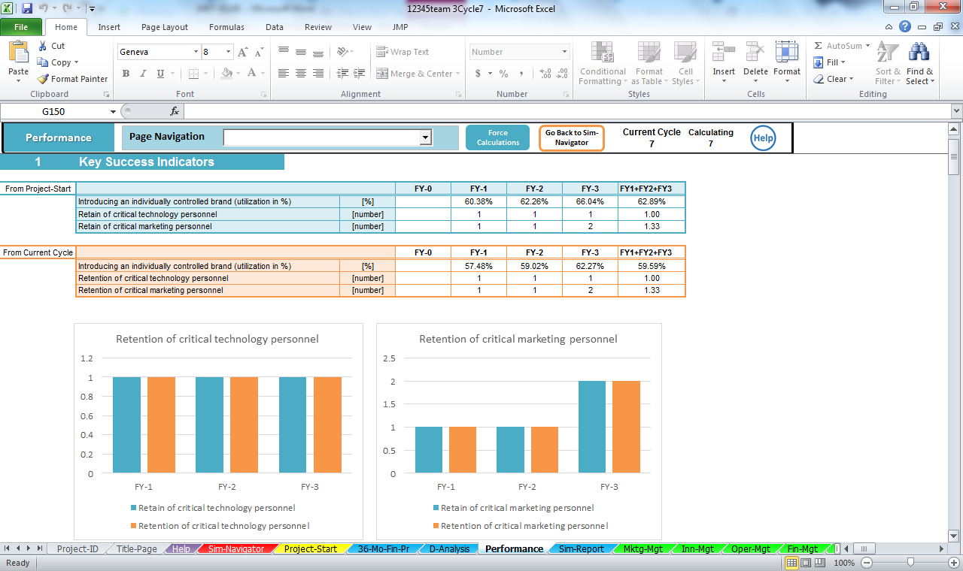
Figure 1: Brewpub Performance
In analyzing the business performance, figure 2 reveals that for both retention of critical technology from the start to current cycle revealing FY-1 at 60.38%, followed by FY-2 at 62.26% and lastly FY1+FY2+FY3 at 62.89%.

1.1 Background Information to Brewery
The oldest recipe in the world is beer. Around 5000BC, the documenting of the brewing process was done by the ancient Egyptians (Zimmerman, 2018). The first beers were brewed using indigenous herbs, dates and pomegranates. As compared to the current standards, the ancient's brews were harsh. The beer was used for religious purposes as the pharaoh controlled the distribution and scheduling of the masses. Before the Egyptians, the primitive cultures of Mesopotamia are considered the first brewers though they never recorded anything concerning beer and the brewing process. They left behind mated scraps of barley and bowls with the residue of beer providing evidence of the brewing process in Mesopotamia. The residue was the remains of grain porridge that were fragmented using yeast having intoxicating impacts on the consumers who repeated the process of brewing.
As time goes by, there was an increase in the demand for beer-making the influx of immigrants of the USA to drove the production of American beer to the new high standards in the later 1800s and early 1900s (Alberts, 2018). Unfortunately, America was affected by the great depression. Between 1920 to 1933, the consumption of alcoholic beverages in the USA was considered illegal (Drug, 2020). Small brewpubs and regional breweries made a great loss in the business. They decided to drop the business and venture into other areas. Some of the brewpubs and breweries managed to survive by making sugar, soda and ice cream. After the repulsion of the prohibition in 1933, the USA was in a great depression making it difficult for the breweries to recover after along rest of 13 years. The loyalty of the brand was eroded and people never had money to purchase the drinks. Beers that expanded during the prohibition became popular leading to mass production of cheap beer. As the sales of beer increased, the cost of beer reduced. The trend of increase in demand and sales continued until the late 1970s and early 1980s, making the number of breweries increase to 2000 by 1983 in the USA (Elzinga, Tremblay & Tremblay, 2018). Tied House Law mandated to make breweries illegal for sale was in effect till the 1970s. From the 1970s, legal exceptions on breweries were passed allowing people to involve themselves in the process of producing beer and setting up brewpubs. Currently, almost 50 states of the USA are permitted the regulated establishment of brewpubs making the number of brewpubs increase in the USA.

1.2 Objective
Between 2012 and 2017, after the full legalization of the beer business in the USA, the number of crafts breweries has gravely increased. This is in response to the high demand for the product. Therefore, there is a great market opportunity for investing in the business. The main objective of starting up a brewpub is to make a profit by producing high-quality products while remaining competitive in the market. Being a new business, the owner needs to evaluate business stimulation tools for faster growth and expansion in the market.

2.0 Business Simulation Models
The owner of the new brewpub needs to consider opportunities in increasing the competitiveness of the industry by investing in the new technology for Brewpub by producing high-quality beer. According to Bridges, et al., (2017), business evaluation is an aimed process of understanding how intervention or policies implemented affects the outcome of the business. Impact evaluation is a particular type of evaluation designed or structured to respond to the question of the impacts of observed were due to the intervention implemented in the business simulation tools. The evaluation of the business stimulation measures the kevel by which the change in the results linked to the intervention. Evaluation helps in understanding the effect of an intervention made on the new Brewpub on the related customers and revenues. Impacts evaluation should be undertaken to determine the new brewpub business helps in reaching the objectives of the business with well-outlined tools. Business simulation tools help in assessing the merits or the importance of intervention on new Brewpub (Ball & MacBryde, 2020). Different business evaluation techniques are combining to establish the objectives outlined. It is important to have a full understanding of the evaluation impacts in the new brewpub industry. Evaluation of the business will be important will help in understanding the operation of the business in different regions where the business will be expanded. The outcomes will be based on profitability, innovation and productivity. Different business stimulation models will be analyzed relating to the Brewpub industry to begin its operation in the USA. The objectives of the business stimulation tool are to provide recommendations and advice for investing in the new venture.
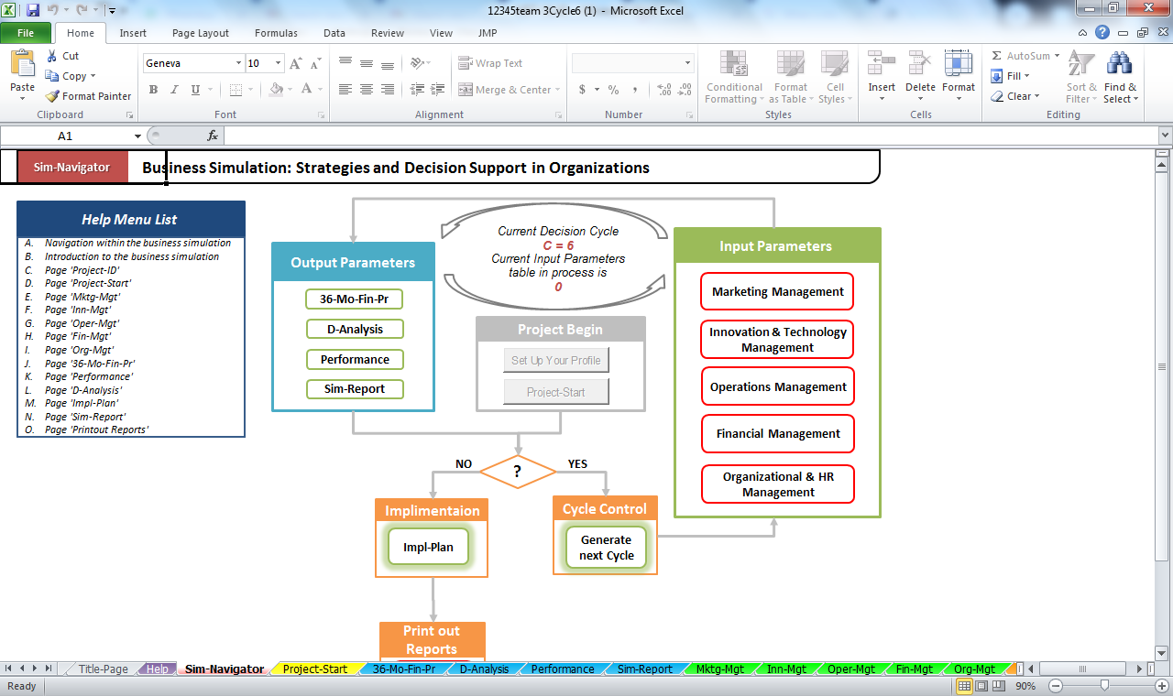
Figure 2: Business Simulation Model

3.0 Management Analysis

3.1 Operations management
Company or operations management occurs in four different types; business operations management, culture health management, organizational/company health management, and leadership capability management within the entire organization or company. Each of these managements has its importance on the future of the said company or organization. For example, the organizational culture management indicates the interactive nature between the employees and the organizational systems put in place (Choi, Wallace & Wang, 2018). This management reveals the loopholes in the said relationship and explores creative ways of improving its culture in the future. On the other hand, business operations management is also crucial as it focuses only on its processes. The evaluation seeks to add more value to these processes by exploring their weaknesses and offering an in-depth review of how the said processes may be improved in the future. Organizational leadership management encompasses the leadership within the entire company and its effectiveness. This management analyzes how effective the organization's leadership is and identifies critical areas of improvement for its management and team leaders. Organizational health management is perhaps the most vital form of company management that an organization can perform (Farmanova, Bonneville & Bouchard, 2018). The review considers all the aspects characterizing the company, including leadership, culture, business practices and business strategies. The management aims to improve the prioritization of a company's goals, business procedures, better organizational structuring, and effective allocation of the available corporate resources.
For sustainability and managing environmental and social responsibility, the brewing industry has been making efforts of using efficient water and energy for quality products. The management is required to make use of a great deal of water in converting a liter of water to beer. The leaders of New Brewpub, to receive such rapid positive change in high revenue, the leaders are defining, acting and monitoring the process of brewing beer to reduce environmental pollution. The sustainability management and blog systems of the new brewpub are offering effective communication on the subject of sustainability into the culture of the organization. The new brewpub has become commonplace exhibiting concerns for the environment and fitting in the brewing industry in terms of marketing and advertisements. The operational management acknowledges the quality of the ingredients used in making the beer such as hops and barley leading to the production of beer with high quality (Melewar & Skinner, 2018). This can be seen from the growth of the revenues in cycles, representing a higher percentage increase in the overall market. The New brewpub is taking advantage of the environmental culture built by operational management as a platform for marketing and selling the products to the consumers. The management is in constant communication with the employees and customers creating a high level of transparency in the documentation of the corporate sustainability presented in the business simulation tool.

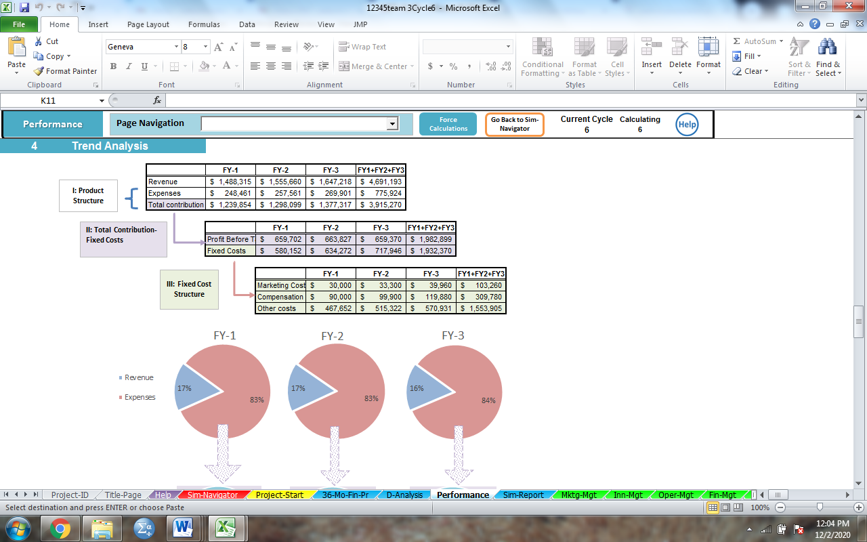
Figure 3: Trend analysis
Under operational management, the company has a predictable trend analysis showing the possibilities of performance increase within the organization. There was a revenues increase for all the years beginning with year FY-1 = $ 1, 488, 315, FY-2 = $ 1, 555, 660, FY-3 =$ 1,647,218 and again FY1+FY2+FY3 = $ 4,691,193.In addition to that, the revenue collected stood at 83% for both FY-1 and FY-2 and FY-3 taking the lead at 84%.

3.2 Organic organizational structure
The organic organization is a business term suggesting the changes like an organization describing the changes and adaption of the changes in the world. This structure is mainly described as flat because it lacks defined leadership levels as in a typical leadership pyramid. In other words, there is no defined flow of power from the employees' level to the senior managerial levels (Leonard, 2018). In this structure, dozens of employees work in clustered groups that are horizontal instead of in vertical clusters. An organization's culture that runs on this type of structure aims to create a harmonious employee culture via the decentralization of managerial duties (Lee & Edmondson, 2017). The employees are encouraged to organize themselves into teams that oversee the completion of specific allocated roles while fostering coordination and participation of different groups (Sollund, 2006). Here, the communication occurs between the various teams and is horizontal as compared to the vertical flow of information from lower to the upper managerial levels in the traditional hierarchical organizational structure. It is also worth noting that many organizations that adopt the organic structure are keen on implementing the open-floor office space design plan in modern times.

3.2.1 Advantages of Organic Organization to Brewpub Company
First, the organic organization structure has flexible approaches to the changes in customer and financial environment. Besides, it has helped the management to be responsive and quick in making changes to adapt to the environment. It has provided several ranging descriptions through providing fluid staff structures in the management. Being a new business. The organic organization will help the business to cope better with the unstable environment. The management will be able to consider all employees in the organization leading to the production of quality beer, satisfying the needs of all consumers. Moreover, the system involved employees in decision-making and problem-solving, enhancing motivation and commitment leading to faster revenue. Finally, the organic organization encourages creativity and innovation amongst the employees. The New Brewpub industry will require more innovation and create new ideas to survive in a competitive environment and make use of technological advancement to remain relevant in the competitive market.

3.2.2 Disadvantages of Organic Organization
Despite having advantages and promoting faster development of New Brewpub industry, an organization may make the staff not be sure with their specific roles and responsibilities leading to confusion in the firm. Besides, due to the high flexibility of organist organization, the decisions made may be vaguely interfering with the daily performance of the company. Finally, the flexibility in the organization can cause instability and uncertainty as the ideas of each employee needs to be considered while making a decision.

3.3 Hierarchical Organizational structure
A hierarchical structure is defined as the command of a chain in the company from the senior management to general workers. Hierarchical structure helps the employees to understand their roles in the organization. They can understand how to advance themselves in the company as those having higher working skills and experience will be given a higher position's in the company. The opportunity of prompting the employees became appealing, thyme thus has higher morale with intrinsic motivation increasing the productivity of the company. In this type of structure, the leadership roles are clearly defined, and a leadership pyramid can be drawn. The interaction between the employees and the management is different when compared to the organic structure (Lee & Edmondson, 2017). Here, the top most management and leadership levels sit at the top of the leadership pyramid and can delegate roles and duties to the employees below them in the pyramid. The leadership is centralized, and team leaders are managers (Sollund, 2006). The communication between the teams and the managers is formalized and appears in a written form. This structure is rigid and stable, especially regarding the delegation of the leadership roles between the different employee levels in the organization (Leonard, 2018). The hierarchical organizational structure is heavily driven by reports that are generated continuously at different organization levels. It is also imperative to note that the leaders in this structure must practice loyalty to the company and cultivate the same with the employees who report to them on different company or organization matters (Sollund, 2006). On the other hand, since the employees are expected to follow the guidelines and directions communicated by their leaders and managers, they ought to have explicit trust in their leaders and the decisions they are expected to follow.
The BrewPub Company is hierarchical. Different workers work under other managers. Hence, the company's decision process flows from the top management to the different levels of employees. Furthermore, the company has four different levels of employees starting with office assistants, salesmen, executive salaries and miscellaneous (Consultants). This hierarchical organization has hyped Brewpub company to clearly define its authority. The employees receive direct supervision easing the flow of communication and ensuring employees know the type of management they are under. Clearly defined executive positions help the company to have father revenue from its sales. This elaborative hierarchical stricture also encourages specialization as various departments have the opportunity of working in a specific field. For example, the managers have a duty of providing their management skills and ensuring the effective daily running of activities in New Brewpub.

3.4 Organization and HR Management
An organization or corporate culture is a critical element that dictates the management and employees' behavior in their transactions with the outside business. It is essential to note that the company culture is dynamic and implied rather than explicit (Sushchenko & Basyuk, 2019). Company culture develops over a long time, derived from the employees' work and ethical characteristics that the company hires. The BrewPub company atmosphere is described using several adjectives. Firstly, the atmosphere is customer-focused and cost-conscious. The company makes striking alliances with money lending organizations and other housing bodied to ensure that the customer can access housing and cheaper and quality housing. These efforts clearly illustrate that the company operates with the customer needs at its core by ensuring that the customers get the most affordable housing options possible. The company is also innovative as it is always researching the best techniques that could be applied to bettering the company's service delivery to the customers. This aspect is also emphasized because it diversified its services to suit a changing business environment and a vast customer base by introducing new services that meet its customers' needs holistically.

3.5 Core Competency Management
Competency management refers to the thorough process of matching the professional and individual characteristics of an employee or an applicant to the business goals and plans. Most organizations today perform competency-based management on their employees and their recruiting process to ensure that they get the right person to complete the company's required tasks (Lasse, 2020). Competency management is an essential tool in quantifying the professional and skill gaps in an individual. The review weighs how (individual behavior) the individual executes what (task). After the measurements are taken, the individual's proficiency is determined and matched against the expected ability to evaluate any possible task and skill gaps.
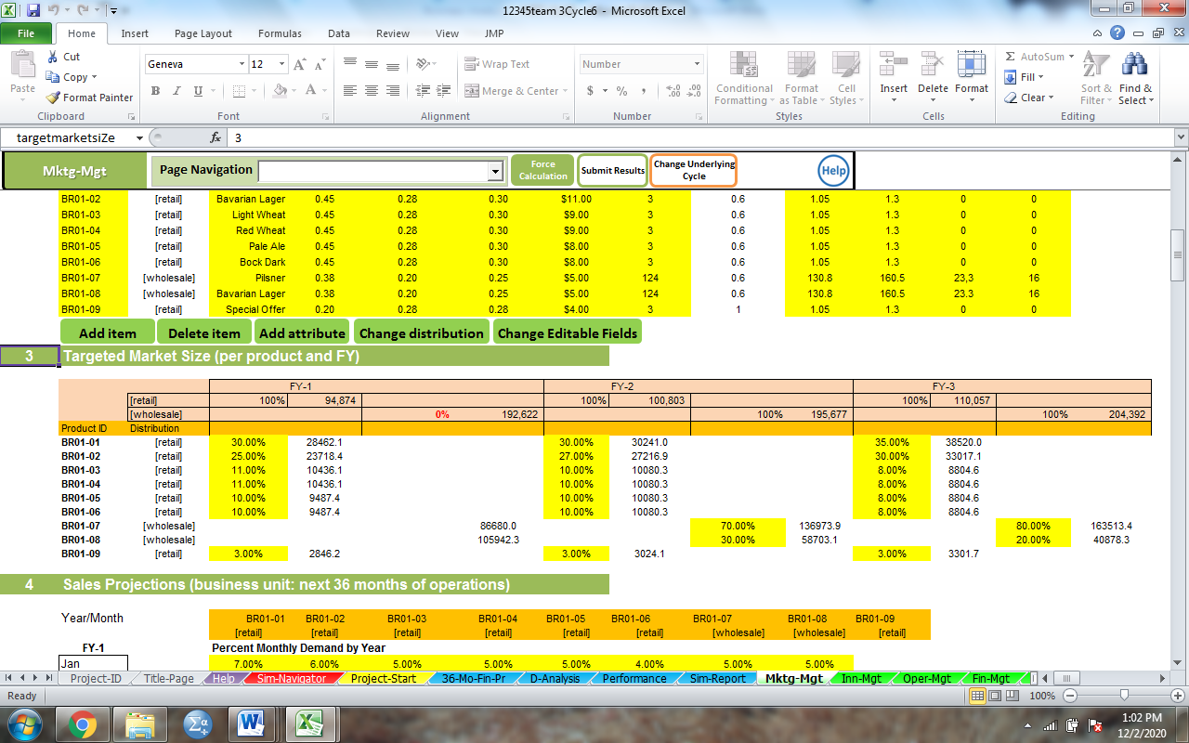
Figure 4: Targeted Market Price (per product and FY)
The target market price is higher in financial year three (FY-3) than the first and the second year (FY-1 and FY-2). The BrewPub Company has a core competency in beer brewing. As earlier illustrated in this text, the company follows a well-defined set of procedures to achieve the best results in both beer brewing and selling. An organization's core competencies refer to those abilities, skills, or experience that set the organization apart from the competitors, thereby creating a competitive advantage for the company. If an organization has a core competency, the capability is translated to the organization's strategic strength or bargaining power in the market space. Core competencies are essential in the creation of new business products and strategies to outdo the competition. Some measures may be applied in the testing and determination of organizational core competency as described below;
- A core competency must pave the way for the development of new business products with an assurance of opening even more expansive market space for the product.
- In addition to the above point, the core competency must be a critical contributor to realizing success for the newly created business product or service.
- The core competency must have no loose ends in that it should be an uphill task for any competitor to copy or reproduce. If the competition copies and replicates the skill or ability, then the competitive advantage that the initial company enjoyed through the skill or experience is lost.
The organizational core competencies are identified and developed over a long period so that they are deeply mastered. The mastered core competencies then become an essential part of the creations and sustainability of the organization's competitive advantage over time (Lasse, 2020). The organization's skill set and abilities, experiences, knowledge, and technologies and techniques used in the company are vital factors in identifying its core competencies. It is critical to note that the firms continue to identify new competencies and apply them in their business processes. These companies' objective is to offer their products and services at a whole new, dynamic, and innovative level. Such organizations continue to perfect their competencies while markets' competencies market trends to develop the futures markets' competencies. The companies look to the future with confidence as they already understood the markets' wants and needs long before getting there.

4.0 Strategical Analysis

4.1 Quality Control and Decisions Making
Quality control is an essential element in any company that seeks the perfection of its products or services and that the quality of these services is retained. Furthermore, quality control brings value to the organization's stakeholders from the most basic level to the managerial level by creating a conducive environment where these different entities are given a chance to execute their assigned duties optimally. Quality is the level or value of excellence in a product or service is. The quality in the beer industry is based on the consistency of producing beer and maintaining the high flavor based on the needs of the consumers (Duarte Alonso, Koko & O'Shea, 2020). Quality control is the process of controlling and maintaining the consistency of the beer. In the beer industry, quality control is based on three aspects which are important for the success of the new brewpub in the competitive market. First, there is high-quality basic instrumentation for monitoring the process of brewing beer. The new brewpub needs to use instrumentation for absolute accuracy in the production of quality beer. For instance, the company can use simple hydrometra to monitor the temperature of the brewed beer as they are fast and easy to use. To nonlife the steps in the process of producing beer, the management needs to use spectrophotometry. The instrument will allow the owner of the business in performing basic analyses such as bitterness and wort color. Most of the consumers of beer prefer the one of high density. Therefore, it is important to monitor the gravity of fermentation. The instrumentation aspects will make the company to control the quality of beer produced. The second aspect of quality considered with the brewery industry is a good sensory program. A good sensory program did not depend on a particular program. It is important to evaluate beer to ensure quality before releasing it to the competitor market. The management needs to focus on the clean and good glassware, a well-established room for performing the sensory and training team members to work in the production of quality beer. The management needs to consider utilities such as software programs. The utilities will help in visualizing and analyzing the deviation of aroma and flavor of beer before coming into the market. The last aspect involves the use of proper methods of helping in changing quality standards. The quality standards lay the foundation for quality control. The most commonly used methods of brewing beer are from the American Society of Brewing Chemists (Bissmeyer & ASBC Technical Committee, 2019), and should be applied by the new brewpub for better-quality standards in the market. The utilities presented in the new Brewpub company have can be sued to explain the rapid change in the revenue for the company. The consistency of the beer is maintained by using well-analyzed methods in the production of the beer. The owner of the business needs to use the valuable opportunity in evaluating the performance and interpretation of the standard method.
Quality control in an organization is achievable through thorough training of employees, product testing, and product benchmarks for quality purposes. An effective control system ought to have clearly defined control procedures to ensure minimal quality losses by specifying the standards to be followed in what products and by which employees. Applebee Brewpub Company takes quality control seriously. The company applies procedures and mechanisms that have already been tested and proven to work in different firms. The company further implements advanced technologies in the resolutions of quality control procedural challenges, meaning that it remains innovative and result-oriented. As the company has accumulated vast experience over the thirty-six years or so that it has been in existence, the quality control mechanisms that it applies while offering property management service to its customers are effective and yield results beyond the expectation. As a result, the company boasts of continually improving and exceptional results compared to other competitors in the same niche. It achieves low resident turnovers, best rental rates in the market, a high percentage of occupancy, and maximum use of the managed properties.
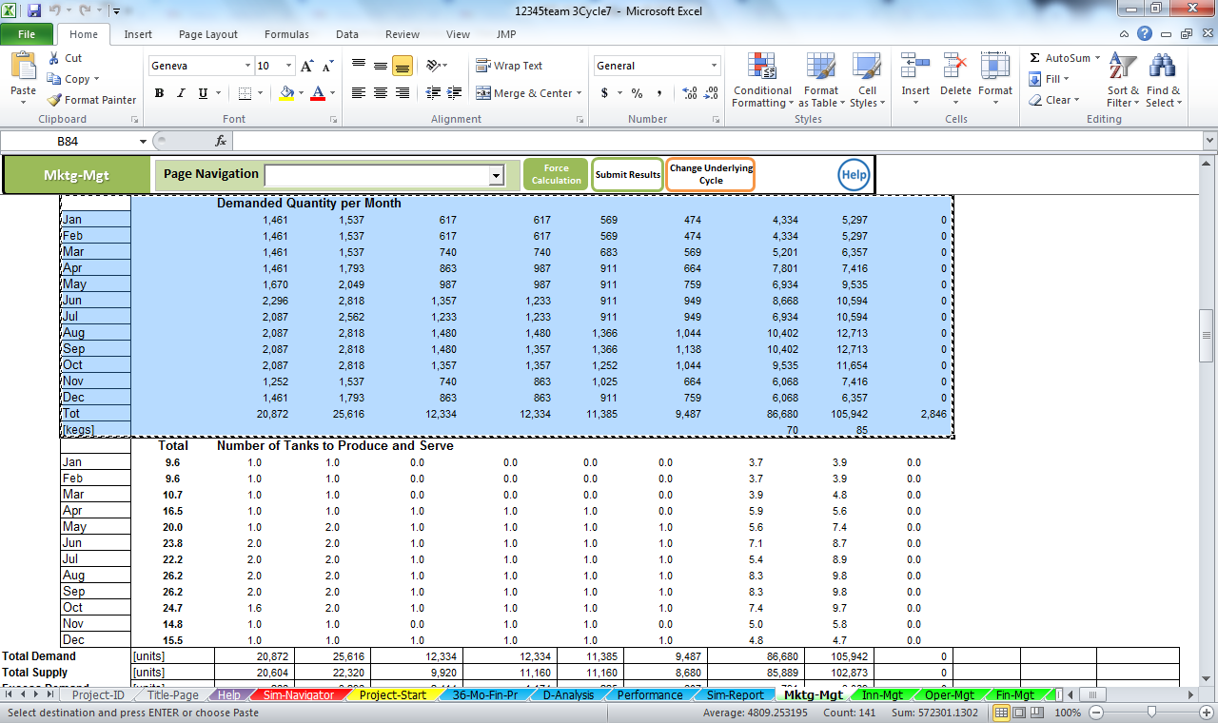
Figure 5: Demanded Quantity per Month
The highest months with more quantity demanding involves May, June, July August and September that entails 1,670,2,296,2,087 and the rest 2,087 as well. The structural design of an organization is a crucial element in the decision-making process within the said firm

4.2 Innovation & Technology Management
According to Applebee BrewPub Management is continually exploring new rising opportunities that can be offered to their clients. The company has a clear focus on technology, which is a clear indicator of its dynamic approach to arising challenges and opportunities. Apart from dealing majorly in property management, the company diversified into affordable housing that would help acquires new properties by their targeted customers and later offer more management work for these newly acquired properties. Furthermore, the company also employs strategic partnerships that are essential in its market acquisition.

5.0 Financial Analysis

5.1 Break-even analysis
A break-even analysis tool helps the company to determine the stage at which the introduction of a new service or product in the company will be profitable. Break-even analysis, as a business stimulation model, is important in determining the number of products to be sold by Brewpub company to cover particularly fixed costs (Morano & Tajani, 2017). At the break-even point, the business is exacted not to make profit or loss but cover the expenditure cost. For the Brewpub company, break-even analysis is critical in studying the interrelationship between fixed cost, revenue and variable cost. A company having a low fixed cist should have a low breakpoint and vice-versa.

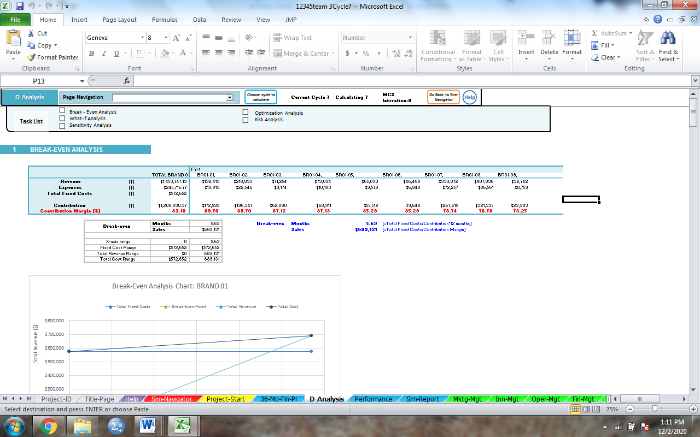
Figure 6: Break-even analysis
The breakeven analysis table revealing that the amount of revenue collected was much higher than the expenses and this proves a point that the company is doing well for every financial year and the profit margin also widens.

5.2 Market Share
Market share is the total percentage of sales generated in the industry for a particular period. Market share is used in providing the idea of the size of the company and its ability to expand in the new market to the competitors (Kotabe & Kothari, 2016). For the new Brewpub company, located in Harvard Square, investors into the company will monitor the decrease and increase in the market share of the company is relative to the competitiveness of the products and services of the company. The company maintaining its market share will grow its revenues at a similar rate as the total market and a faster rate compared to the competitors. An increase in the market share for the Brewpub company allows it to have a greater scale with its improved profitability and operation.
For the Brewpub company, it has been projected to penetrate the new market yearly, thus increasing its market share. The rate of consumption of beer is increasing from the first cycle due to the higher performance of the company in the market. The annual sales of the company are constant within a year but shows an increase in the subsequent years. The stock performance of the company is increased, increasing the margin of the sale. From the provided data, the increase in market share for the Brewpub company is attributed to different factors. First, the company has employed qualified employees who are offering quality services and are paid well (90, 0000) for year one. Within the subsequent years, the salary of the employees is increased thus intrinsically motivated. Besides, the company is making use of new technology in the advertisement and marketing of the products. This creates loyalty amongst the consumers as they perceive the products to be of better quality as compared to other competitors. The market share of the company increase the firm inverts more in new technology as evidenced in the data from the first cycle to the last cycle. Finally, the employees within the Brewpub company have created customer loyalty. Strengthening the relationship helps the organization to protect the existing market share by preventing the current consumers of the product to shift to competitors. The customers are therefore frequently satisfied making them speak positive experience to the friends who become new customers thus increasing the revenue without increasing the expense.

6.0 Conclusion
Every customer is always interested in the different craft of beer and brewing culture. The industry created the room required by local people in creating their awareness of the brewing culture. Based on the result analyzed, the information shows how new brewpub will be successful in the competitive market. The business simulation models used have presented enough evidence on the success of the company in the comparative world (Komarova, et al., 2019). From the results, the organizational structure plays a key role in the success of the company. It determined the flow of information from the top executives to employees. The effective flow of information and involvement of the employees in decision making can be concluded to be some of the key factors for the success of the company. The rapid increase in revenue is due to customer loyalty and relationship with the employees in the organization. This increased the market share making the company make a profit daily. Being a new business, the use of new technology led to faster expansion in the competitive market. The marketing and advertisement of the new products were easily done by committed employees to various locations in Harvard. The hierarchical organization of the company ensured specializations of the employees and hard work as those with high skills and experience were easily promoted to higher levels. The organic organization ensured workers participate fully in the management and offering of services as they were consulted while making decisions influencing the operation of the company (Kulkarni, Robles-Flores & Popovič, 2017). The company increased the salary of its employees every year. Organizing the operation of the business into cycles made it easy for the management of the company to effectively control the operation of the company at each level. The wall elaborated management skills are responsible for the high break-even point for the business and increased revenues. Thus, the company will succeed in the competitive market if the management continues to use the same business stimulation models or improve in the analysis of the success of the company.

7.0 Recommendations
The business of beers is currently expanding so much across the globe. The upcoming business in this sector needs to venture more to expand in the competitive market. The New Brewpub industry to be opened in Harvard Square is not exempted. For the business to succeed in the competitive market, the following are recommended:
First, the management needs to ensure continuous use of modern technology in marketing, adverting and responding to the needs of the customers. Currently, the world is digitalized. Most of the customers are obtained online on Facebook, twitters, and Instagram. Thus, for continuous improvement, the management needs to open up official social media sites where the advertisement and marketing of the products can be done.
Besides, the company should use programmed tools to provide high-quality beer to the customers. The beer business is very competitive at Harvard. If the quality of produced beer does not meet the standards of the consumers, the market share will be reduced. The break-even point of the company will also reduce.
Moreover, the location of the new brewpub is not such bad. Despite located locally, the management should have thought of expanding the business into urban areas where more people use beer. The expansion will increase the revenue for the company.
Furthermore, there is high competition in the market. The management of the new business needs to analyze the products and prices of the competitors. This will help the new business to realize the weakness of the competitors and improve their products and attracting more customers. But if the management will be reluctant to realize this, the competitors will have an advantage and eventually defeat the new business expanding into the market.
Finally, the management must employ qualified personnel with high skills and experience. The employees should be motivated to work for the success of the business but not for money. In response to this, the management must ensure they retain highly qualified employees in all sectors and departments and motivate them by promotion and increasing salaries.

References
Alberts, B. (2018). Beer to Stay: Brewed Culture, Ethnicity, and the Market Revolution (Doctoral dissertation, Purdue University).
Ball, P., & MacBryde, J. (2020). Developing a framework for adopting environmental manufacturing practices: learning from breweries. Production Planning & Control, 1-16.
Bazzani, G. (2020). Business intelligence technologies for marketing and sales: customer data management and analysis at we localize Lifesciences.
Bissmeyer, D., & ASBC Technical Committee. (2019). Validating the Sensitivity of the Beer Tetrad Test as Compared with the Beer Triangle Test: An American Society of Brewing Chemists Technical Committee Report. Journal of the American Society of Brewing Chemists, 77(3), 220-221.
Bridges, J., May, C., Fuller, A., Griffiths, P., Wigley, W., Gould, L., ... & Libberton, P. (2017). Optimizing impact and sustainability: a qualitative process evaluation of a complex intervention targeted at compassionate care. BMJ quality & safety, 26(12), 970-977.
Choi, T. M., Wallace, S. W., & Wang, Y. (2018). Big data analytics in operations management. Production and Operations Management, 27(10), 1868-1883.
The drug, U. S. (2020). The Long Shadow of Prohibition. The Oxford Handbook of American Political History, 481.
Duarte Alonso, A., Kok, S., & O'Shea, M. (2020). Peru's emerging craft‐brewing industry and its implications for tourism. International Journal of Tourism Research.
Elzinga, K. G., Tremblay, C. H., & Tremblay, V. J. (2018). Craft Beer in the USA: Strategic connections to macro-and European brewers. Economic Perspectives on Craft Beer (pp. 55-88). Palgrave Macmillan, Cham.
Farmanova, E., Bonneville, L., & Bouchard, L. (2018). Organizational health literacy: a review of theories, frameworks, guides, and implementation issues. INQUIRY: The Journal of Health Care Organization, Provision, and Financing, 55, 0046958018757848.
Kotabe, M., & Kothari, T. (2016). Emerging market multinational companies’ evolutionary paths to building a competitive advantage from emerging markets to developed countries. Journal of World Business, 51(5), 729-743.
Kulkarni, U., Robles-Flores, J. A., & Popovič, A. (2017). Business intelligence capability: the effect of top management and the mediating roles of user participation and analytical decision-making orientation. Journal of the Association for Information Systems, 18(7), 1.
Lasse, C. (2020). What is Competency Management? Association for Talent Development. Retrieved from https://www.td.org/insights/what-is-a-competency-management
Lee, M. Y., & Edmondson, A. C. (2017). Self-managing organizations: Exploring the limits of less-hierarchical organizing. Research in organizational behavior, 37, 35-58.
Leonard, K. (2018). Organic Structure of Organizational Design. Chron. Retrieved from https://smallbusiness.chron.com/organic-structure-organizational-design-58657.html#:~:text=The%20organizational%20design%20of%20a,structure%20is%20a%20centralized%20approach.
Melewar, T. C., & Skinner, H. (2018). Territorial brand management: Beer, authenticity, and sense of place. Journal of Business Research.
Morano, P., & Tajani, F. (2017). The break-even analysis applied to urban renewal investments: a model to evaluate the share of social housing financially sustainable for private investors. Habitat International, 59, 10-20.
Simon, T., Nayeem, A. R., Alam, M. K., & Raja, M. S. A. (2020). Impact of Choppies Enterprise in Southern Africa: An Exploratory Study on Strategic Management Perspective. American Economic & Social Review, 6(1), 30-38.
Sollund, R. (2006). Mechanistic versus organic organizations' impact on immigrant women's work satisfaction and occupational mobility. Scandinavian Journal of Hospitality and Tourism, 6(4), 287-307.
Sushchenko, O., & Basyuk, D. (2019). Organization of Personnel Training in the HR-Management System at Machine-Building Enterprises. In MATEC Web of Conferences (Vol. 297, p. 07006). EDP Sciences.
Zimmerman, J. (2018). Brew Beer Like a Yeti: Traditional Techniques and Recipes for Unconventional Ales, Gruits, and Other Ferments Using Minimal Hops. Chelsea Green Publishing.

Appendix
Figure 1: Performance of Brewpub

Figure 2: Business Simulation Model

Figure 3: Trend Analysis

Figure 4: Targeted Market Price (per product and FY)

Figure 5: Demanded Quantity per Month
Figure 6: Break-Even Analysis

